AI- WEATHERWISE PROJECT

Project titles: AI- WEATHERWISE PROJECT
Team ID: SWTID-2026-2998
Team leader: PAVITHRA R.P
Karanpavithra2006@gmail.com
Team members:
DIVYA DHARSHINI.S: divyadharshinidharshini70@gmail.com
SRIMATHI I: srimathii390@gmail.com
DURGA SRI S: durgasiva5678@gmail.com

INTRODUCTION
Weather information is an important part of everyday life, travel, agriculture, and business planning. A weather monitoring system collects, processes, and presents information such as temperature, humidity, wind speed, weather conditions, and forecasts. Weather data can include current conditions, location-based observations, historical information, and forecast details. Providing timely and understandable weather information helps users plan their daily activities and make informed decisions.

In today’s connected environment, accessing reliable weather information quickly is very important. Without timely weather information, users may face difficulties in planning travel, outdoor activities, agriculture, and other weather-sensitive work. Therefore, weather applications use digital systems to retrieve weather data, display current conditions, and provide forecasts for selected locations. These systems help users access weather information quickly and understand changing conditions.

Weather monitoring also plays an important role in planning and decision-making. It helps people prepare for changes in temperature, rainfall, wind, and other atmospheric conditions. Modern weather applications use APIs, databases, web technologies, and responsive interfaces to retrieve and present accurate weather information.

The main goal of Weather Wise is to provide useful weather information in a simple, clear, and accessible form. It helps users understand current conditions and plan activities based on weather forecasts. An effective weather application improves user experience by making important weather information available whenever users need it.

This project focuses on understanding weather monitoring, its importance in daily life, and the technologies used to collect and display weather information. It also highlights how a user-friendly weather system can support planning, safety, and informed decision-making.

SOURCE CODE
const mongoose = require('mongoose');
const connectDB = async () => {
try {
const conn = await mongoose.connect(process.env.MONGO_URI || 'mongodb://127.0.0.1:27017/weatherwise');
console.log(`MongoDB Connected: ${conn.connection.host}`);
} catch (error) {
console.error(`Error connecting to MongoDB: ${error.message}`);
process.exit(1);
}
};
module.exports = connectDB;
const { generateSummary, generateRecommendation } = require('../services/aiService');
const getWeatherSummary = async (req, res) => {
try {
const { city, temperature, humidity, condition } = req.body;
if (!city || temperature === undefined || humidity === undefined || !condition) {
return res.status(400).json({
success: false,
message: 'Please provide all fields: city, temperature, humidity, and condition'
});
}

const summary = await generateSummary(city, Number(temperature), Number(humidity), condition);
return res.json({
success: true,
summary
});
} catch (error) {
console.error('Error in getWeatherSummary:', error.message);
return res.status(500).json({
success: false,
message: 'Server error while generating weather summary'
});
}
};
const getWeatherRecommendation = async (req, res) => {
try {
const { temperature, condition } = req.body;

if (temperature === undefined || !condition) {
return res.status(400).json({
success: false,
message: 'Please provide all fields: temperature and condition'
});
}

const recommendation = await generateRecommendation(Number(temperature), condition);
return res.json({
success: true,
recommendation
});
} catch (error) {
console.error('Error in getWeatherRecommendation:', error.message);
return res.status(500).json({
success: false,
message: 'Server error while generating weather recommendations'
});
}
};
module.exports = {
getWeatherSummary,
getWeatherRecommendation
};
Project overview
AI WeatherWise is developed as a robust RESTful backend platform using Node.js, Express.js, MongoDB, and Mongoose ODM. It provides real-time weather metrics and uses Google Gemini AI to generate intelligent summaries and personalized recommendations. help users access and understand weather information efficiently and accurately. It allows registered users to manage favorite cities and retrieve weather information for selected locations. The system retrieves current weather metrics and supports AI-powered summaries and recommendations. By using this system, users can reduce the effort required to interpret raw weather data and make better activity-planning decisions. It also helps users prepare for changing weather conditions and plan weather-sensitive activities. The project aims to provide a secure and user-friendly solution for retrieving weather information, managing favorite locations, and receiving AI-driven insights.

Mongodb connect page
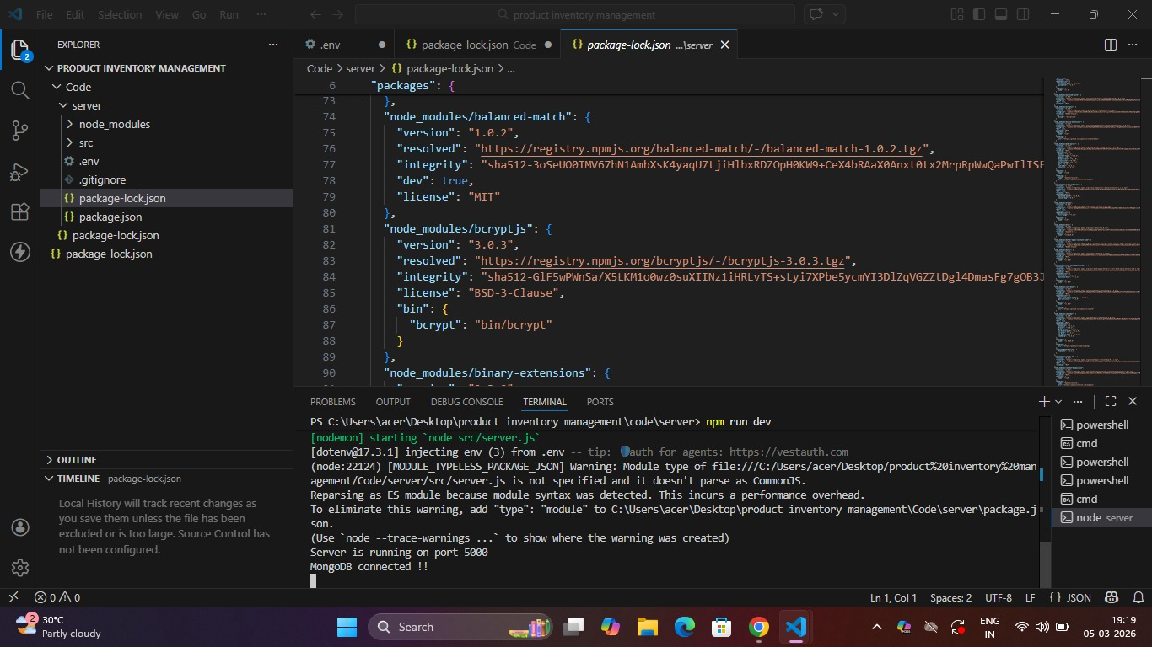

Project Architecture
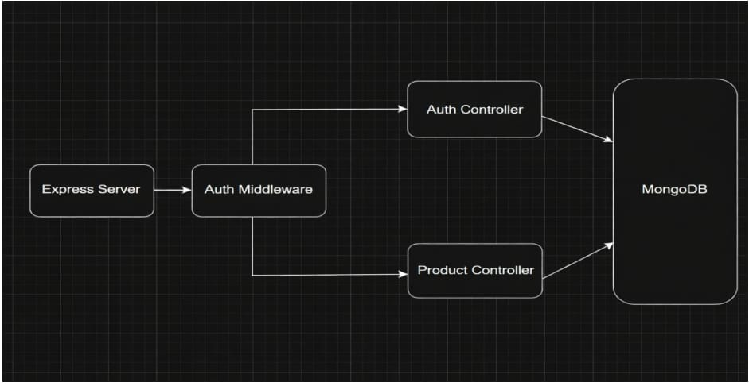

AI WeatherWise uses a simple *MVC architecture* with Node.js, Express.js, and MongoDB
Main Components:
Frontend / API: Sends requests to the system.
Node.js + Express: Handles API requests and responses.
Authentication:Uses JWT for secure login.
Weather API:Gets current weather information.
Gemini AI: Provides weather summaries and recommendations.

TECHNICAL ARCHITECTURE
• Controllers: Handle authentication and weather logic
• Models: Define database schemas
• Routes: API endpoints for authentication, locations, and weather
• Middleware:JWT verification and error handling
• Configuration: Environment variables and database connection

Database Architecture (MongoDB)

Users Collection:

• _id
• name
• email
• password(hashed)
• timestamps

Locations Collection:

• _id
• userId
• city
• country
• createdAt

Backend development:

Setup Express Server:
Inside src/server.js, create the basic Express server.

Create controllers:
Inside: src/controllers/
Create:
auth.controller.js

Auth Controllers
Authentication Controller
The Authentication Controller manages all user authentication-related operations in the AI WeatherWise system. It handles user registration and login while ensuring secure access using JWT tokens.
Responsibilities
● Register new users
● Validate user input data
● Hash passwords using bcrypt before storing
● Authenticate users during login
● Generate JWT tokens for authorized access
● Send appropriate success and error responses
Main Functionalities
● Register User: Creates a new user account after validating email uniqueness and securely hashing the password.

Weather controllers.js

Weather Controller
The Weather Controller handles all product inventory operations and contains the business logic for managing products linked to individual users
Responsibilities
● Register new users
● Validate user input data
● Hash passwords using bcrypt before storing
● Authenticate users during login
● Generate JWT tokens for authorized access
● Send appropriate success and error responses

Main Functionalities
● Register User: Creates a new user account after validating email uniqueness and securely hashing the password.
● Login User: Verifies user credentials and returns a JWT token for secure access to protected APIs.

Create middeware:
Create :
Auth.routes.js

Create Models:
Inside src/models/ create:
● User.js
● location.js
User model:

location model:

Project Execution
Execution Steps
1. Open the terminal in the AI WeatherWise server folder.
2. Make sure the start script is configured in the package.json file.
3. Run:
npm start
4. Console should display:
AI WeatherWise server running on PORT
Database Connected

Output:

Register user:
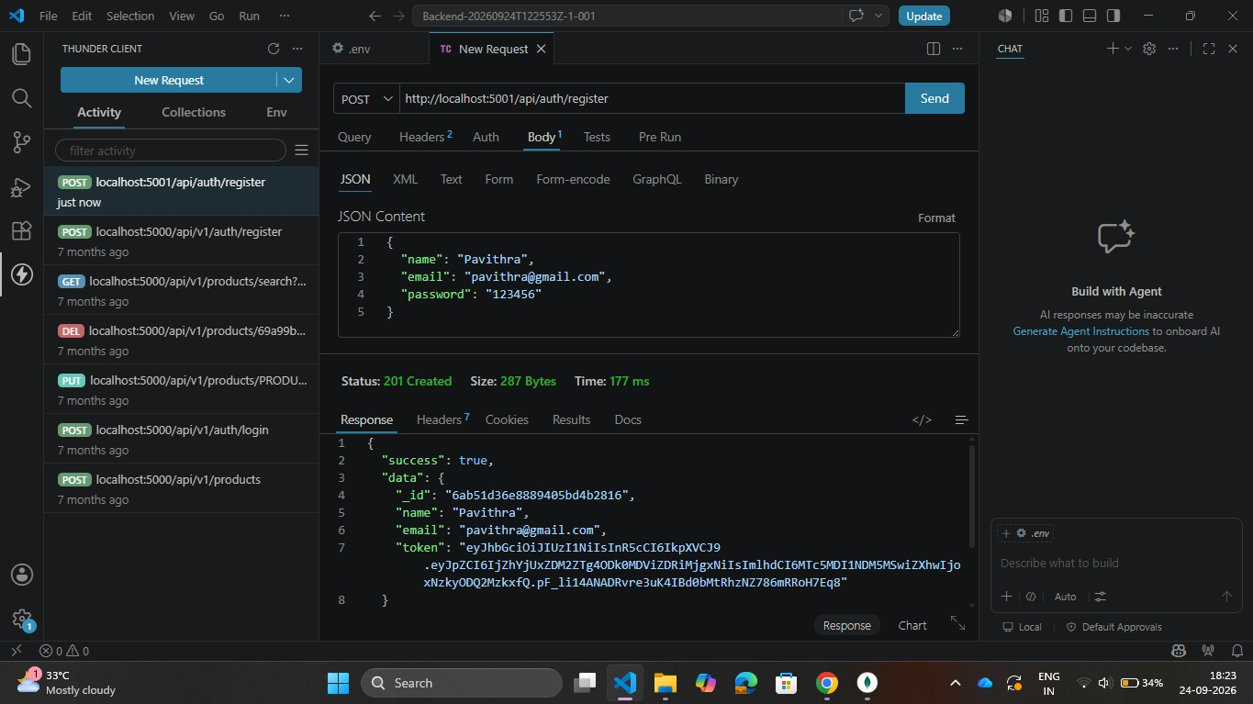
Register:
The register functionality allows new users to create an account by submitting their details ,which are validated are securely store with a hashed password.

Login user:
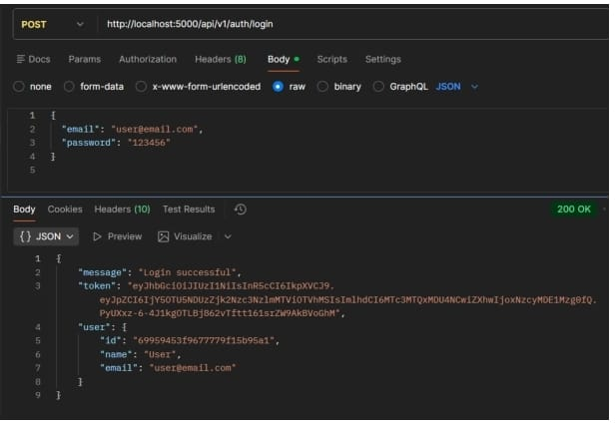
Login:
The login functionality verifies users credentials are generates a JWT token upon successful authentication .
This token is used access protected routes securely

Fetch weather:
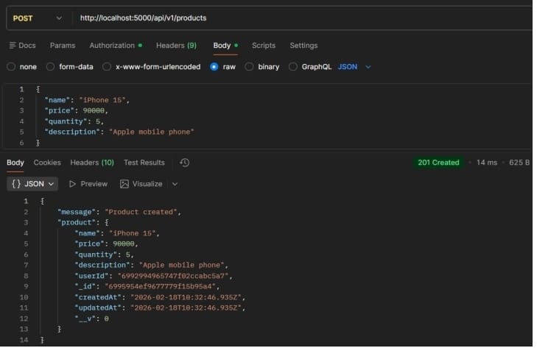
Get weather information:

Get weather information
Fetches weather information for the selected location and returns current conditions and forecast details.
Update locations:

Manage favorite location
Enables users to manage favorite location details. The system verifies ownership before allowing updates.

Delete favorite location
Delete favorite location
Allows users to remove a favorite location from their account. The operation is protected so only the owner can delete it.

DEMO LINK
https://drive.google.com/drive/folders/1RiB5cKHe3a-MhKUP0HPlzMz_jRkCD4gE?usp=sharing
DRIVE LINK:
https://drive.google.com/drive/folders/19HiRU_wLwkxJHJaFGgLOYUc8m0KxS9TU?usp=sharing

